Azure Scenario

1. You are having a public conference where in you would like to share certain documents with the members attending your conference keeping in mind that the document link will be valid to the attendees only during the conference.

Configure the above by using an appropriate service of azure.

Create a storage account

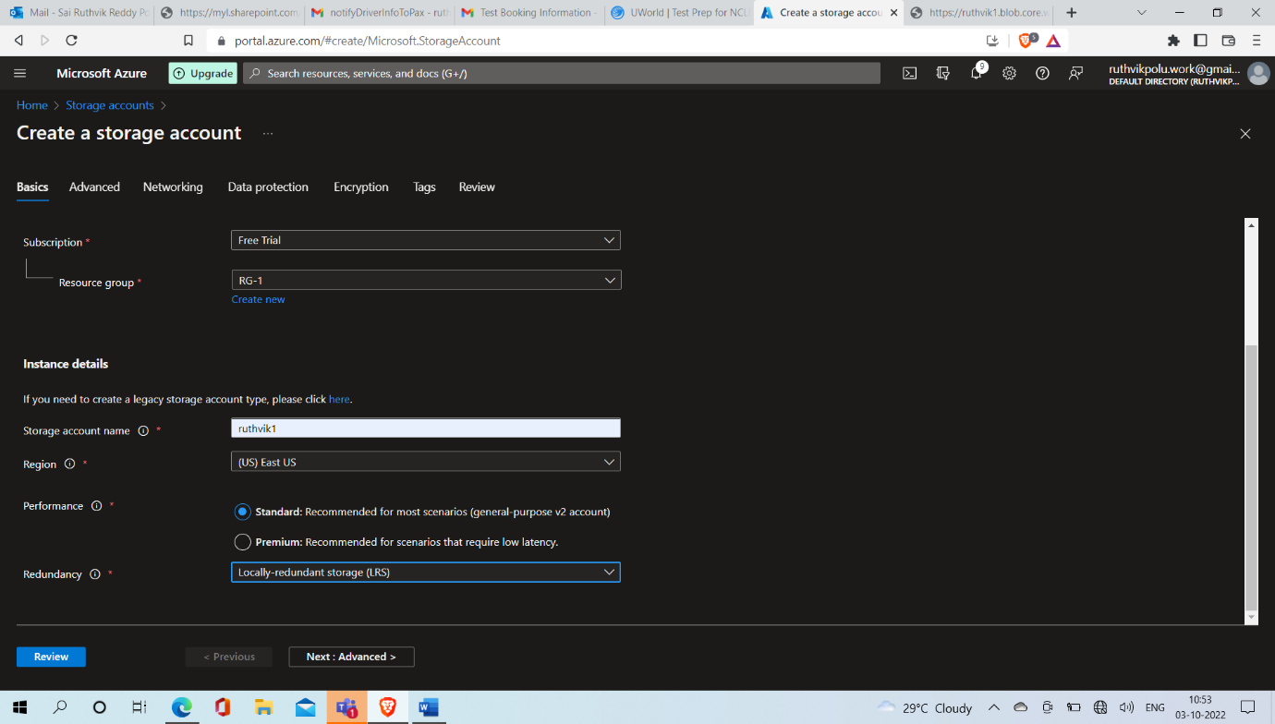

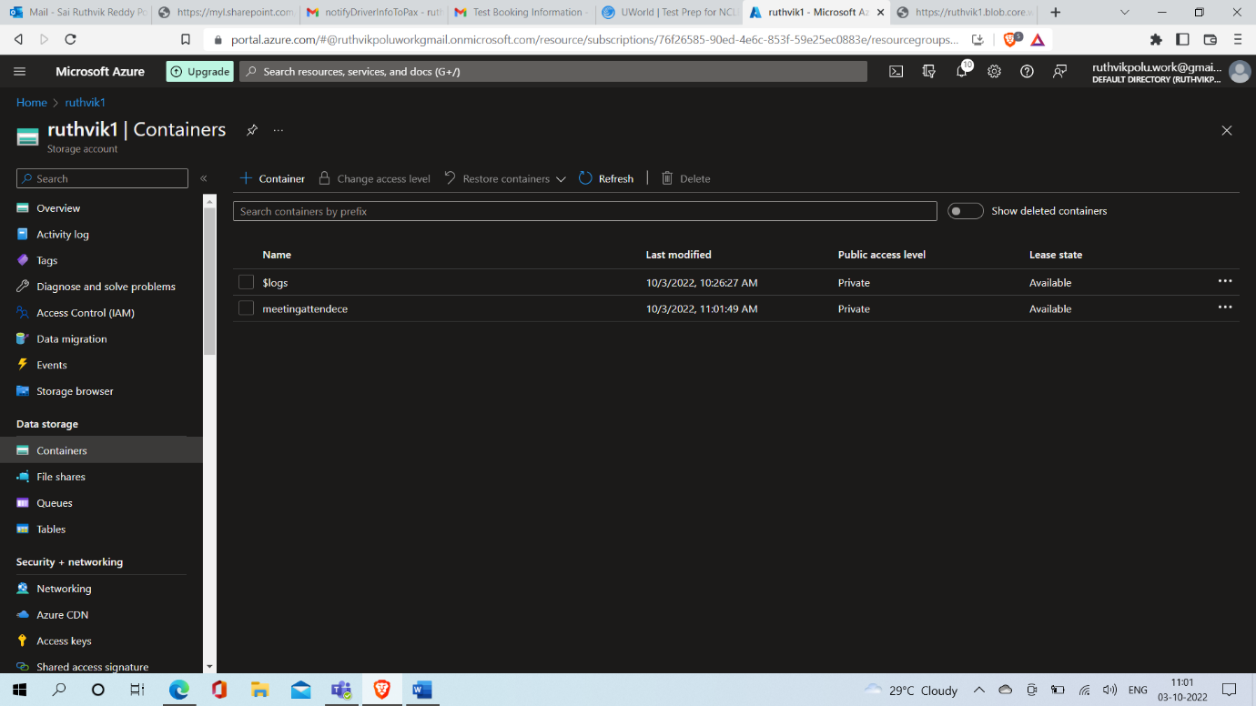

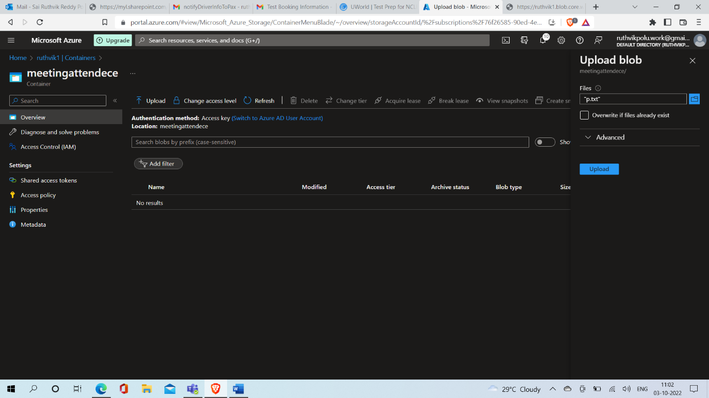

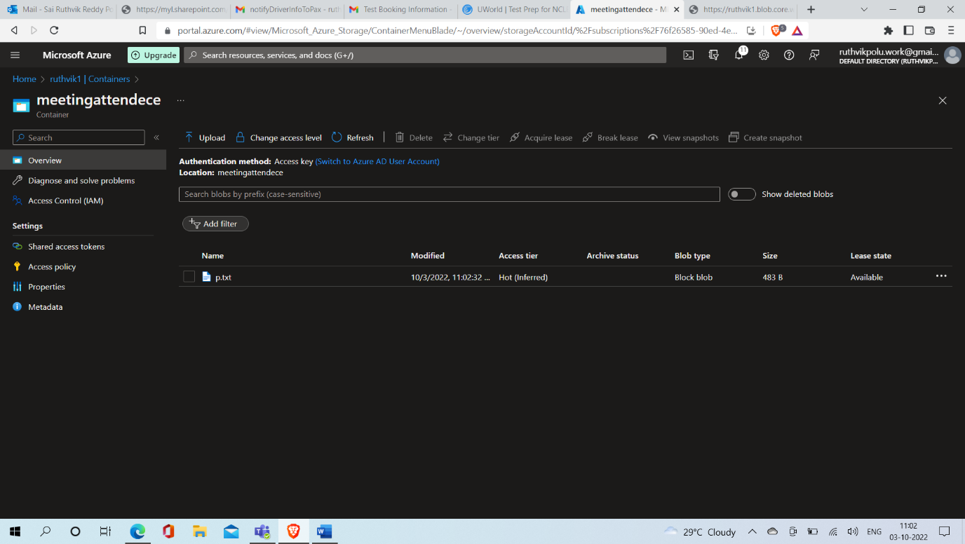

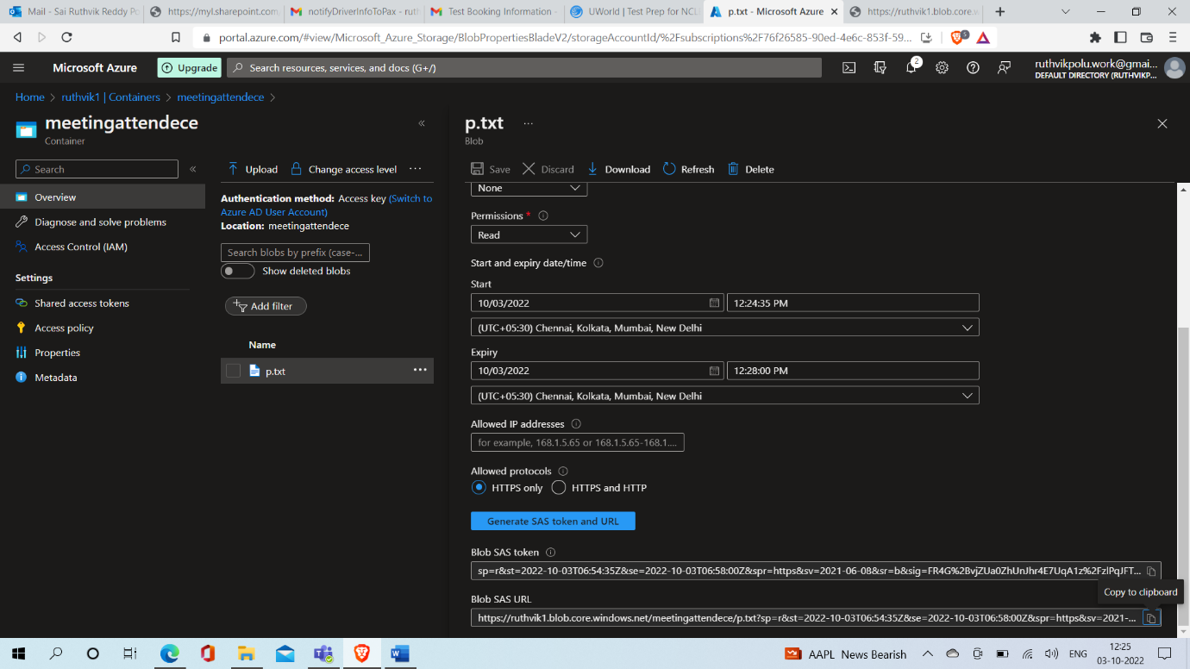

The link will work from 12:25 PM to 12:28 PM

After the time limit URL won’t work.

